Task 3 – Infrastructure as Code

Create a YAML file for the CloudFormation template:

AWSTemplateFormatVersion: '2010-09-09'
Description: Basic AWS Infra with VPC, EC2, IAM Role, and ECR

Parameters:
VpcCIDR:
Type: String
Default: 10.0.0.0/16
PublicSubnetCIDR:
Type: String
Default: 10.0.1.0/24
KeyName:
Type: AWS::EC2::KeyPair::KeyName
Description: Name of an existing EC2 KeyPair for SSH access
Default: mahi
EcrRepoName:
Type: String
Default: node-sample-app

Resources:

# VPC
MyVPC:
Type: AWS::EC2::VPC
Properties:
CidrBlock: !Ref VpcCIDR
EnableDnsSupport: true
EnableDnsHostnames: true
Tags:
- Key: Name
Value: DevopsTask-VPC

# Internet Gateway
MyInternetGateway:
Type: AWS::EC2::InternetGateway
Properties:
Tags:
- Key: Name
Value: DevopsTask-IGW

AttachGateway:
Type: AWS::EC2::VPCGatewayAttachment
Properties:
VpcId: !Ref MyVPC
InternetGatewayId: !Ref MyInternetGateway

# Public Subnet
PublicSubnet:
Type: AWS::EC2::Subnet
Properties:
VpcId: !Ref MyVPC
CidrBlock: !Ref PublicSubnetCIDR
MapPublicIpOnLaunch: true
Tags:
- Key: Name
Value: DevopsTask-PublicSubnet

# Route Table
PublicRouteTable:
Type: AWS::EC2::RouteTable
Properties:
VpcId: !Ref MyVPC
Tags:
- Key: Name
Value: DevopsTask-PublicRouteTable

PublicRoute:
Type: AWS::EC2::Route
DependsOn: AttachGateway
Properties:
RouteTableId: !Ref PublicRouteTable
DestinationCidrBlock: 0.0.0.0/0
GatewayId: !Ref MyInternetGateway

SubnetRouteTableAssociation:
Type: AWS::EC2::SubnetRouteTableAssociation
Properties:
SubnetId: !Ref PublicSubnet
RouteTableId: !Ref PublicRouteTable

# Security Group
InstanceSecurityGroup:
Type: AWS::EC2::SecurityGroup
Properties:
GroupDescription: Allow SSH and HTTP
VpcId: !Ref MyVPC
SecurityGroupIngress:
- IpProtocol: tcp
FromPort: 22
ToPort: 22
CidrIp: 0.0.0.0/0
- IpProtocol: tcp
FromPort: 80
ToPort: 80
CidrIp: 0.0.0.0/0
Tags:
- Key: Name
Value: DevopsTask-SG

# IAM Role for EC2
EC2IAMRole:
Type: AWS::IAM::Role
Properties:
AssumeRolePolicyDocument:
Version: '2012-10-17'
Statement:
- Effect: Allow
Principal:
Service:
- ec2.amazonaws.com
Action:
- sts:AssumeRole
ManagedPolicyArns:
- arn:aws:iam::aws:policy/AmazonEC2ContainerRegistryFullAccess
Tags:
- Key: Name
Value: DevopsTask-EC2Role

EC2InstanceProfile:
Type: AWS::IAM::InstanceProfile
Properties:
Roles:
- !Ref EC2IAMRole
InstanceProfileName: DevopsTask-EC2InstanceProfile

# EC2 Instance
MyEC2:
Type: AWS::EC2::Instance
Properties:
InstanceType: t2.micro
ImageId: ami-0d176f79571d18a8f # Amazon Linux 2 (free tier)
KeyName: !Ref KeyName
SubnetId: !Ref PublicSubnet
SecurityGroupIds:
- !Ref InstanceSecurityGroup
IamInstanceProfile: !Ref EC2InstanceProfile
Tags:
- Key: Name
Value: DevopsTask-EC2Instance

# ECR Repository
MyECR:
Type: AWS::ECR::Repository
Properties:
RepositoryName: !Ref EcrRepoName
ImageScanningConfiguration:
ScanOnPush: true
Tags:
- Key: Name
Value: DevopsTask-ECR

Outputs:
VPCId:
Description: VPC ID
Value: !Ref MyVPC
PublicSubnetId:
Description: Public Subnet ID
Value: !Ref PublicSubnet
EC2InstanceId:
Description: EC2 Instance ID
Value: !Ref MyEC2
ECRRepository:
Description: ECR Repository Name
Value: !Ref MyECR

- This CloudFormation template provisions AWS resources including a VPC with its components (subnet, route table, internet gateway), an EC2 instance with an associated IAM role and instance profile, and an ECR repository.

Steps to Deploy:

- Click Create stack With new resources (standard).
- Upload your yaml file.
- Provide parameter values if required, or leave them as the default.
- Click Create stack.
- Wait for the stack status to reach CREATE_COMPLETE.

Screenshots of Resources Created by CloudFormation:

Cloudformation stack:

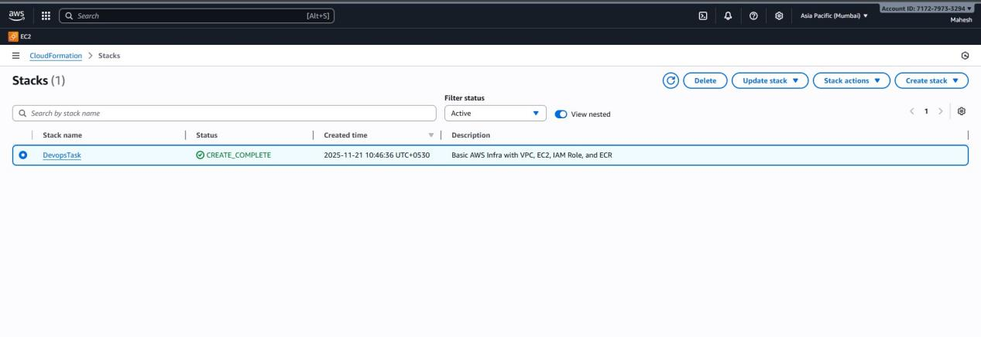

Ec2 Instance:

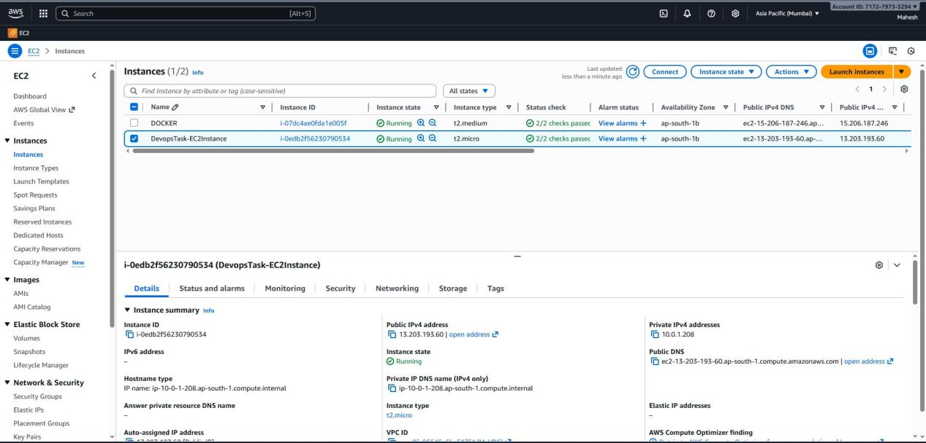

Ec2 Security group:

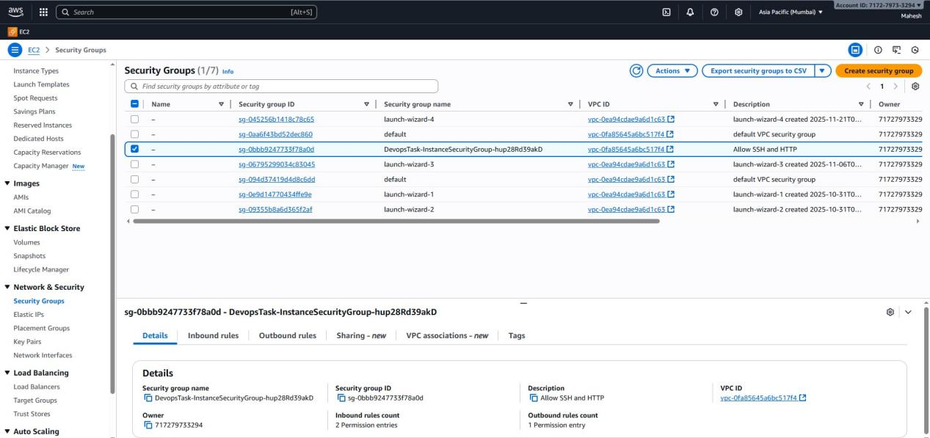

Vpc:

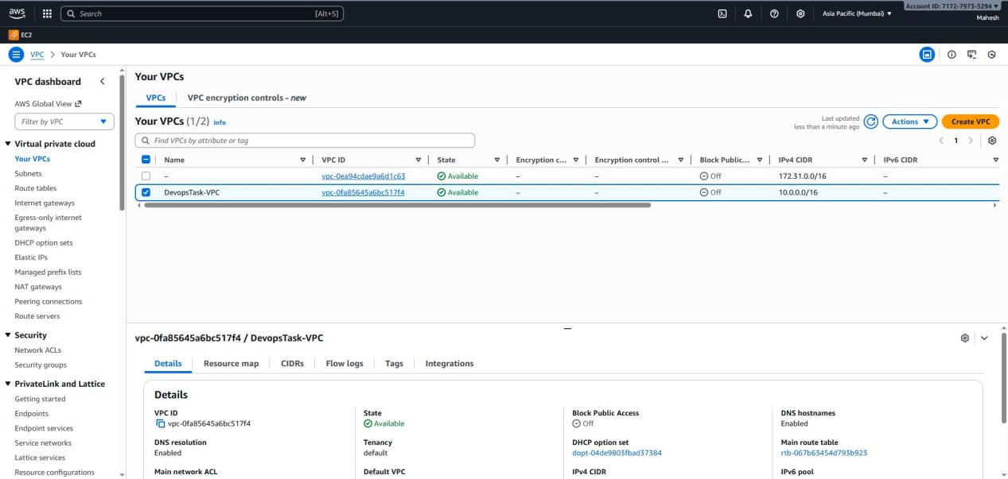

Public Subnet:

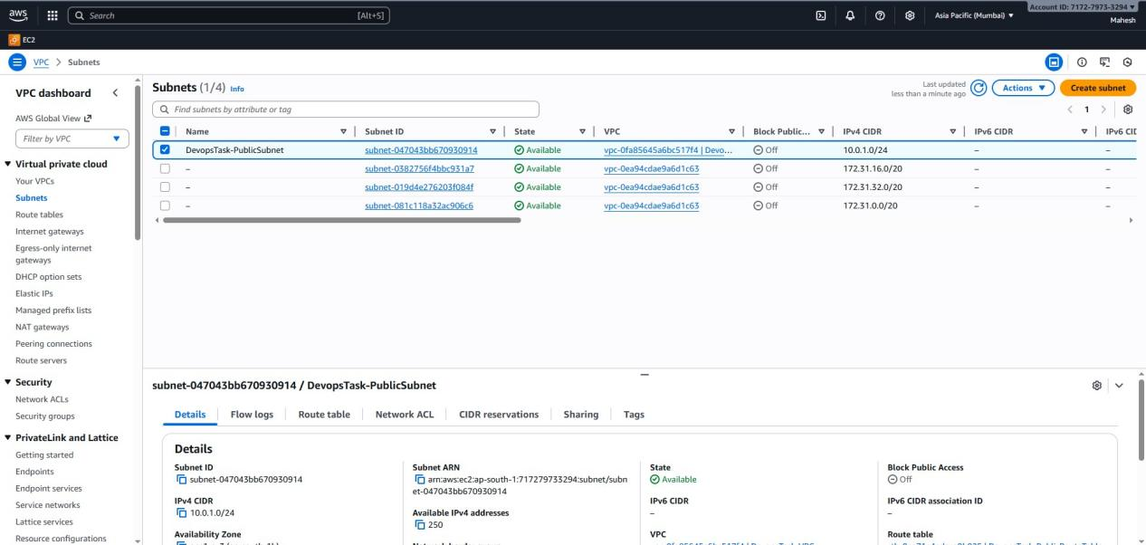

Route table:

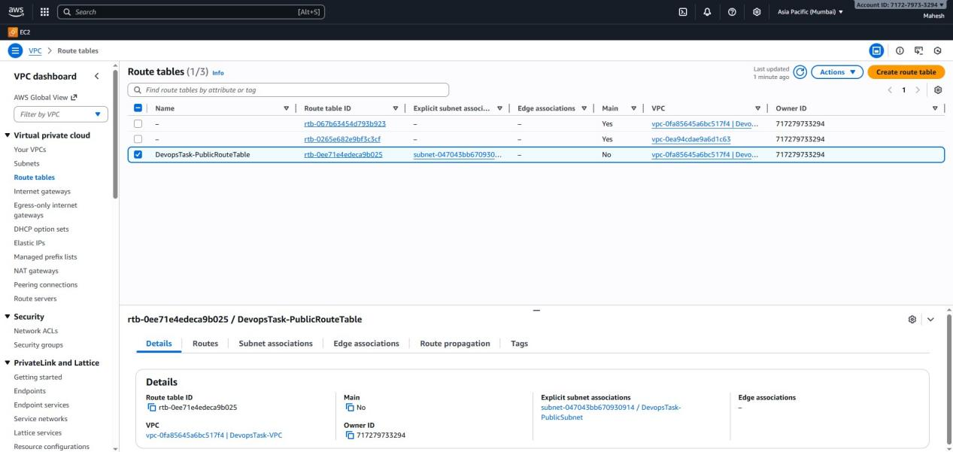

Internet gateway:

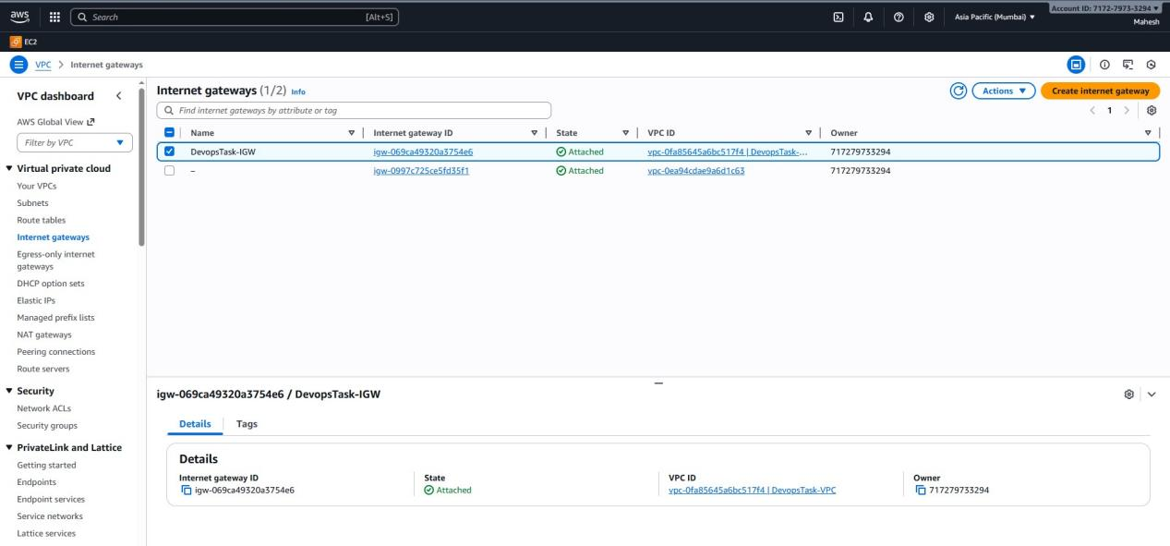

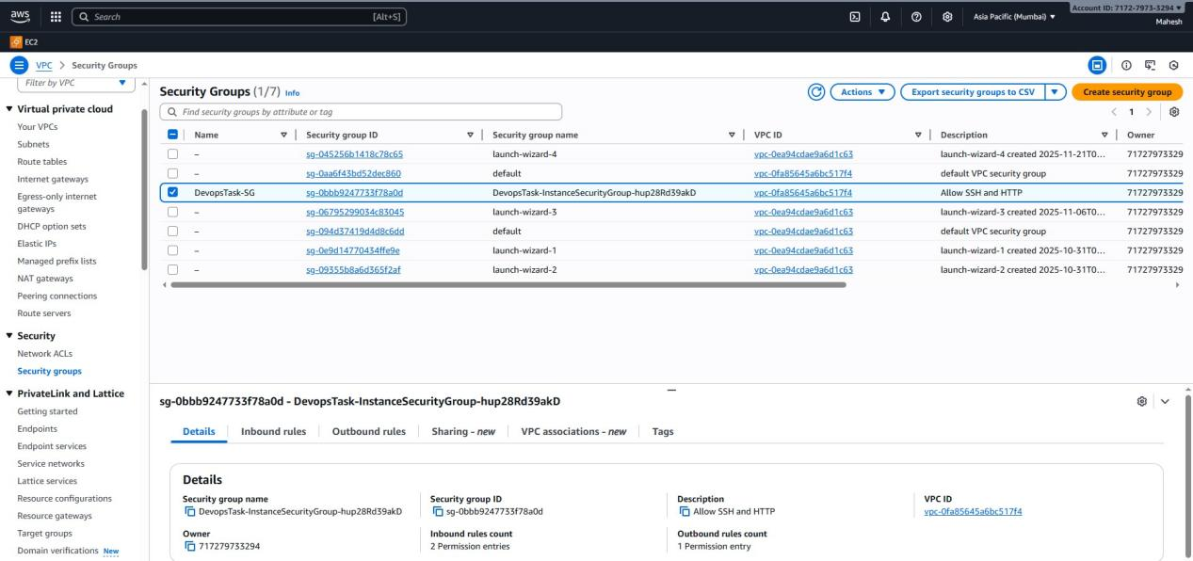

ECR:

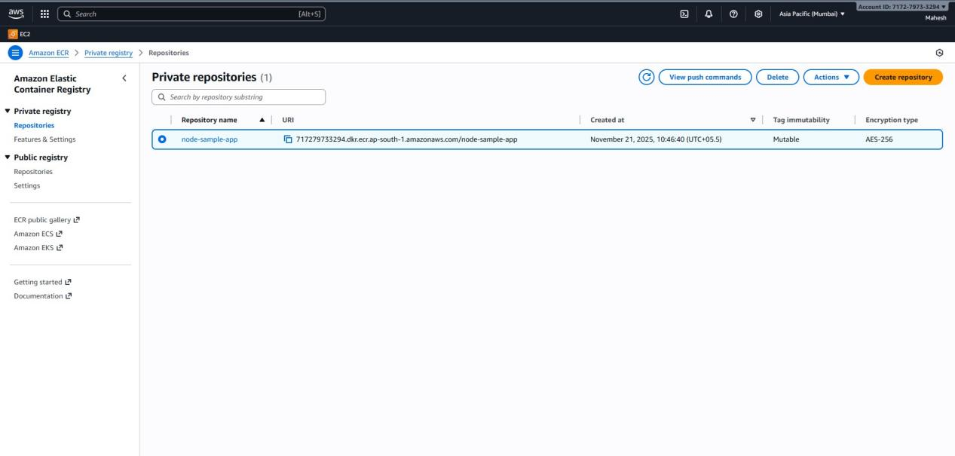

IAM roles:

